

**2ND SEMESTER 2021/2022 ACADEMIC YEAR**

**END OF SEMESTER EXAMINATION ANSWER BOOKLET**

THE FOLLOWING DETAILS MUST BE COMPLETED BY THE STUDENT

400

ADS19A00110Y

STUDENT’S ID NUMBER­­­­­­­­­­: _______________________________ LEVEL:__________

IT403/CS408

Human Computer Interaction

COURSE COD**E: _________** COURSE TITLE:_________________________________

EMMANUEL ADOTEY PAPPOE

LECTURER’S NAME: (Refer to the Question Paper) ________________________________

**QUESTION NUMBER: (e.g., Q1) ___1___SUB-QUESTION (e.g., 1(a)) _1A, B, C_**

1. Architecture of GSM Cellular Network areas;

* Mobile Station (MS): a part of the GSM mobile communication system that is accessible to and controlled by the user. Both phone and packet data services are provided by it.
* Base System Substation (BSS): manages the radio access tasks, such as signaling and traffic between mobile phones and the GSM 2G network's NSS.
* Network Switching Substation (NSS): The user core network, which serves as the entire mobile network's primary control data network and interface.
* Network Management Substation (NMS): used to keep track of the network's numerous features and operations. Its features include performance management, configuration management, and fault management.

1. With the diagram;

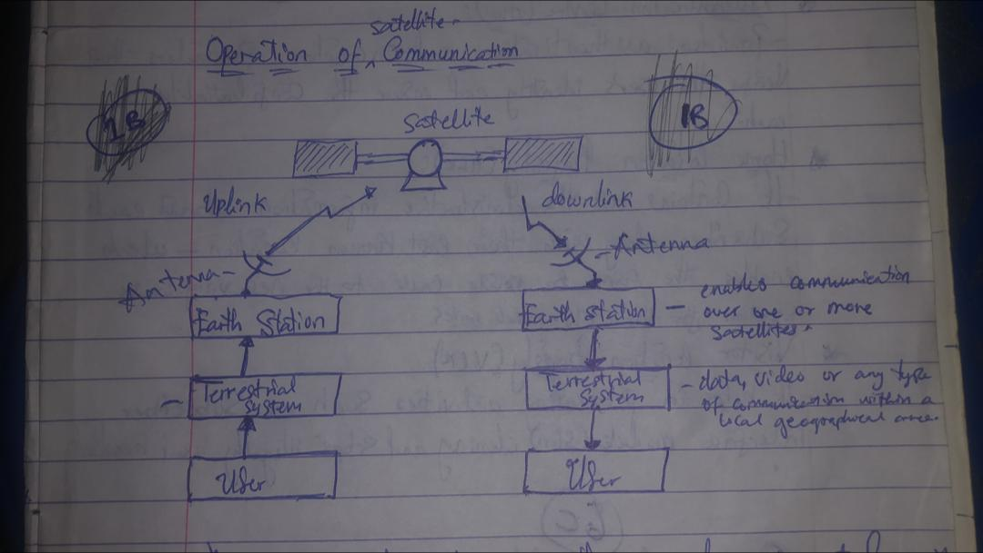

* The designed is transmitted to the satellite by an uplink earth station or other piece of ground technology.
* The incoming signal is received and processed by the satellite by altering its frequency and amplification.
* The signal is returned to earth by the satellite.
* The signal is picked up by ground-based devices.

1. Call roaming in Mobile telephony: It is a process of extending cellular service connectivity in a location that is different from the home location where the service was registered.

The occasion will be sim-based which is a roaming facility that takes place when a user switches the sim-card in to a mobile phone from a different network or across technologies. The security feature that handles it is the username/password based which is whereby GSM subscribers roams on to a public WLAN operated by their GSM operators or another who has a roaming agreement with their GSM operator.

**QUESTION NUMBER: (e.g., Q1) ___2___SUB-QUESTION (e.g., 1(a)) _2A, B, C_**

1. Reason why the shape of a cellular cell is HEXAGONAL

It is hexagonal because if a circle were used, there might be an overlap between any two such neighboring circles or a gap between their coverage regions. Hexagonal is utilized to prevent this.

Mathematically Explanation of cluster size of cell that has the shift parameters **I = 2 & j = 1**;

Formula;

**N = i2 + i*j + j2**

**= 22 + 2*1 + 12**

**= 4 + 2 + 1**

**= 7**

Diagram of the reuse cells

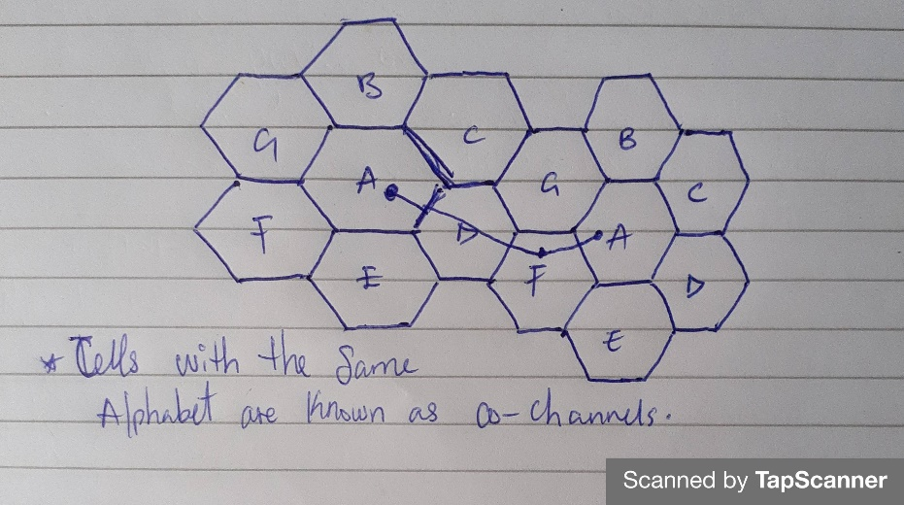

1. Cellular Concept and three factors of cellular concept in Mobile Telephony:

A cellular concept is a system-level theory that suggests replacing one large, high-power transmitter with many smaller, lower-power transmitters, each of which covers just a small section of the service area. By frequently reusing, it expands the capacity of the system.

There are many factors but only three will explained and they are;

**Cell Sectioning**: One Omni-directional antenna is switched out for three or six directional antennas (1200 Sectioning), depending on the application (60 Sectioning). Each cell has three or six sections. Each sector has a set of channels assigned to it and utilizes a directional antenna at the base station.

**Hand-off/Hand over**: It is a procedure wherein the mobile switching center (MSC) immediately changes the call to a new channel assigned to the next cell when a mobile phone moves from one cell to the next during a call. It is comparable to a first call request. It must to be effective, frequent, and unreachable by the user.

**Frequency**-**Reuse**: In order to provide service to a bigger number of mobile customers while having the same constrained frequency range, it is the procedure of allocating the same frequency to two or more non-adjacent cells. Only FDMA & TDMA networks (GSM) have this implementation; CDMA networks do not. The same channel set is used by cells with the same alphabet (clusters). In a cluster, no channel is reused.

1. Advantages of satellite communication

* It eliminates the need for maintenance and intercontinental cable installation costs.
* The likelihood of high usage makes the satellite commercially appealing.
* Because they can cover a lot of ground, they are especially helpful in sparsely inhabited places.

Disadvantages

* The bandwidths that are available are overloaded.
* The expensive initial investment and insurance expenses due to the high likelihood of failure.
* The satellite will eventually need to be replaced (to upgrade technology, "falling" out of orbit).
* Technological constraints hinder the development of big antennas on satellite platforms.

**QUESTION NUMBER: (e.g., Q1) ___4___SUB-QUESTION (e.g., 1(a)) _4A, B, C_**

1. Satellite orbits in terms of Altitude, Number of satellites to cover the world and Applications:

* GEO: Three GEO satellites can cover the whole earth's surface, which is 35,863 kilometers above it along the equator. It offers a continuous picture of a certain location. revolves at the same rate that the earth does around it. Examples: broadcast television, meteorological information, and slow data transmission.
* MEO: it is located between 8000 and 18000 kilometers above the earth's surface. Compared to LEO, they have a significantly wider coverage area. The earth's surface may be covered by six MEO satellites. Examples of GPS and other navigational software.
* LEO: It is 500 to 1500 kilometers away from the surface of the earth. They are only visible for 15 to 20 minutes with each pass and do not maintain a constant location in relation to the earth's surface. less energy is needed to embed a satellite there. minimal communication bandwidth requirements.

1. With the diagram below;

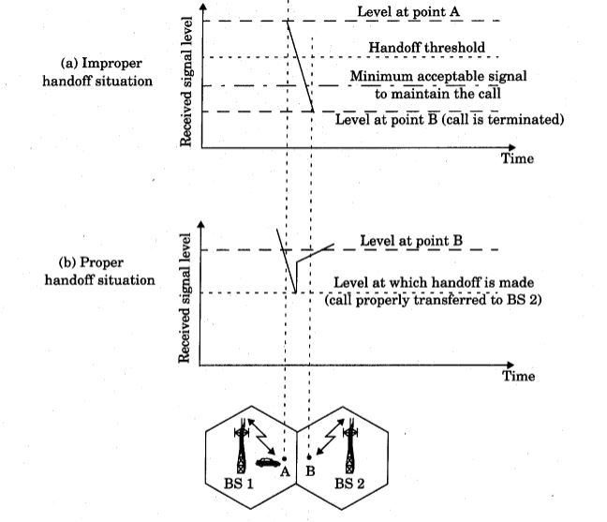

Handoff threshold is crucial for correctly carrying out handoffs. Unnecessary handoffs will occur if the signal level is too far above the minimum signal level, and frequent call disconnections will occur if the signal level is too near to the minimum signal level.

The first handoff occurs when the device is travelling away from point A, causing the signal strength to degrade from BS1. The handoff process begins when the signal level falls below the handoff threshold. However, the handoff was not completed before the signal level dropped below the minimal signal level necessary to sustain the call, thus when the device reached point B, the call was severed. This may occur when the MSC's handoff takes longer than expected or when the threshold level is near to the minimum signal level necessary, leaving insufficient time for the handoff to be completed.

In the second scenario, the handoff operation begins at the threshold level. Before the signal level decreases to the minimum needed signal level, the handoff is finished, and the device is given to BS2. As a result, the signal level starts to increase since it is coming closer to BS 2. As a result, the call is not terminated and is successfully moved to BS 2 without disconnecting. Delta value, or the difference between the minimum signal level and the threshold level, is therefore extremely important.

1. **Calculating for Cluster size (N), Reuse ratio (Q), Reuse distance (D)**

When I =2, j = 2 and R = 60m

Using the formula;

= 22 + 2*2 + 22

= 4 + 4 + 4

**N = 12.**

**Q** = $\sqrt{3}*12$

= $\sqrt{3}6=6$

**D** = $60\sqrt{3*12}$

= $60\sqrt{3}6$

=60*6

= **360**

**Calculating for Cluster size (N), Reuse ratio (Q), Reuse distance (D)**

When I =3, j = 1 and R = 70m

Using the formula;

= 32 + 3*1 + 11

= 9 + 3 + 1

**N** = 13.

**Q** = $\sqrt{3}*13$

= $\sqrt{3}9=6.2$

D = 70 $\sqrt{3}*13$

= $70\sqrt{3}9$

= 70 * 6.2

**= 437.4**

**QUESTION NUMBER: (e.g., Q1) ___5___SUB-QUESTION (e.g., 1(a)) _5A, B, C_**

1. **D**
2. the differences between the following Mobile Radio Transmission Systems:

Simplex:

* Consists of one-way communication
* One-way communication methods
* include radio broadcasting, television, and paging systems.

Simplex is a one-way communication system (Uni-directional communication).

Half-duplex:

* Has two-way communication but not simultaneous communication.
* For instance, walkie-talkie

Allows for two-way communication, but does not provide simultaneous transmission and reception of information in both directions at the same time (non-bidirectional communication). It has push-to-talk and release-to-listen functions.

Full – duplex:

* It Has a two-way communication system and also uses simultaneous communication.
* Like cell phones

Allows a subscriber and a base station to communicate through radio in real time (two-way simultaneous communication).

1. Critical conditions in satellite design;

* The transponders, or numerous channels that make up a satellite, deliver power and bandwidth across specific radio frequencies.
* The amount of data that can be broadcast by the transponder and the size of the ground equipment required to receive the signal are determined by the transponder's bandwidth and power.
* The signal is also directed over a certain geographic area by the satellite antennas.

**QUESTION NUMBER: (e.g., Q1) ___6___SUB-QUESTION (e.g., 1(a)) _6A, B, C_**

1. Security Features that can be found in the NSS

Authentication Centre (AUC):

* Offers authentication and encryption characteristics that validate user identities and guarantee each party's privacy.

Home location Registry (HLR):

* The GSM can route calls to the appropriate base station for the Mobile switch since it maintains all the administrative data about each user, including their last known position.

Visitor Location Registry (VLR):

* It aids in stopping illegally used mobile devices and subscriber interface module (sim) cloning.

1. H
2. Commercial satellite communication services:

Fixed satellite services (FSS):

The majority of our local and international services are supported by business networks made possible by global internet access. It receives and transmits satellite signals using ground equipment at a fixed point.

Mobile satellite services (MSS):

It offers communication services for clients who are land mobile, marine, and aeronautical using a range of transportable receiver and transmitter equipment.

Broadcast satellite services (BSS):

It offers extremely little ground equipment while providing great transmission power for reception. Direct to consumer television and broadband applications are its most well-known uses (direct tv).